Project Title: Light Indicator
Link: https://wiki.microduino.cc/index.php/Light_Indicator

ORIGINAL:
Here we make a simple light indicator, which divides light value into three levels, that is, green, blue and red.
EDIT:
This light indicator project takes the analog output from a light sensor, and turns on an LED to a color that corresponds to that output. The possible analog values are divided into three ranges that correspond to a different LED color, either green, blue or red.
This project is a great introduction into using the data from a sensor to drive the behavior of an output device.

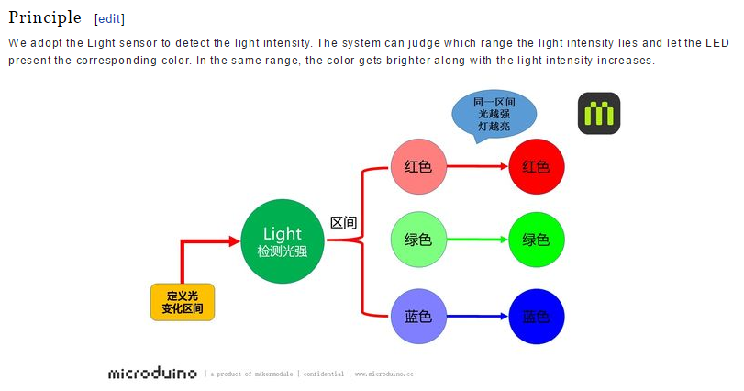

ORIGINAL:
We adopt the Light sensor to detect the light intensity. The system can judge which range the light intensity lies and let the LED present the corresponding color. In the same range, the color gets brighter along with the intensity increases.
EDIT:
The photoresistive sensor detects ambient light intensity. The system we build for this tutorial divides the total range over which the photoresistor can detect light into three smaller ranges, each corresponding to a particular color; either red, blue or green. As the intensity of light increases within one of these ranges, so will the corresponding intensity in the LED color of that particular range.
NOTE: INFORMATION ON GRAPHIC SHOULD BE DUPLICATED IN ENGLISH

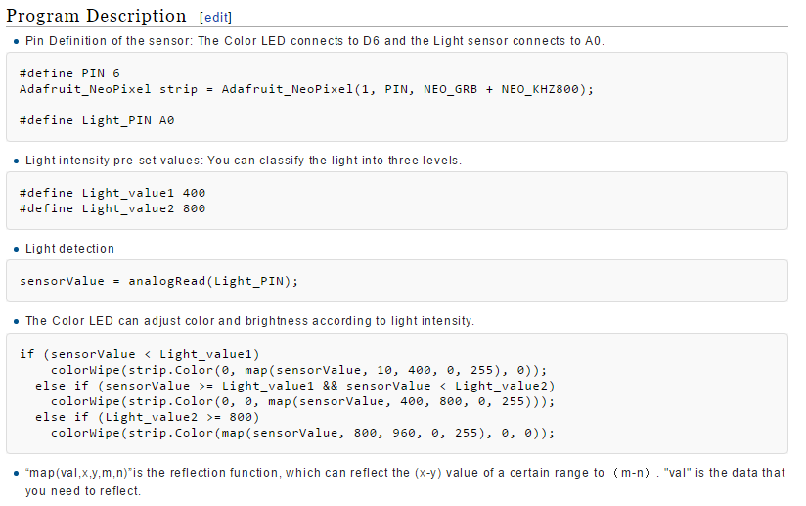
ORIGINAL:
- Light detection
sensorValue = analogRead(Light_PIN);
- The Color LED can adjust color and brightness according to light intensity.
if (sensorValue < Light_value1)
colorWipe(strip.Color(0, map(sensorValue, 10, 400, 0, 255), 0));
else if (sensorValue >= Light_value1 && sensorValue < Light_value2)
colorWipe(strip.Color(0, 0, map(sensorValue, 400, 800, 0, 255)));
else if (Light_value2 >= 800)
colorWipe(strip.Color(map(sensorValue, 800, 960, 0, 255), 0, 0));
- “map(val,x,y,m,n)”is the reflection function, which can reflect the (x-y) value of a certain range to （m-n）. "val" is the data that you need to reflect.

EDIT:
- Retrieve analog value from photoresistor
- The “map(val, x, y, m, n)” is a function that will automatically scale a value(val) from one range (x through y) to another (m through n). For example, the photoresistor outputs values from 0-1023, but the LED only accepts values from 0-255, so if the above function returns a sensor value of 500:
  - 500 * (255-0)/(1023-0) = ~125

